# Setup instruction

## Setup for google chrome

Go to <https://chrome.google.com/webstore/detail/requestly-redirect-url-mo/mdnleldcmiljblolnjhpnblkcekpdkpa?hl=en>

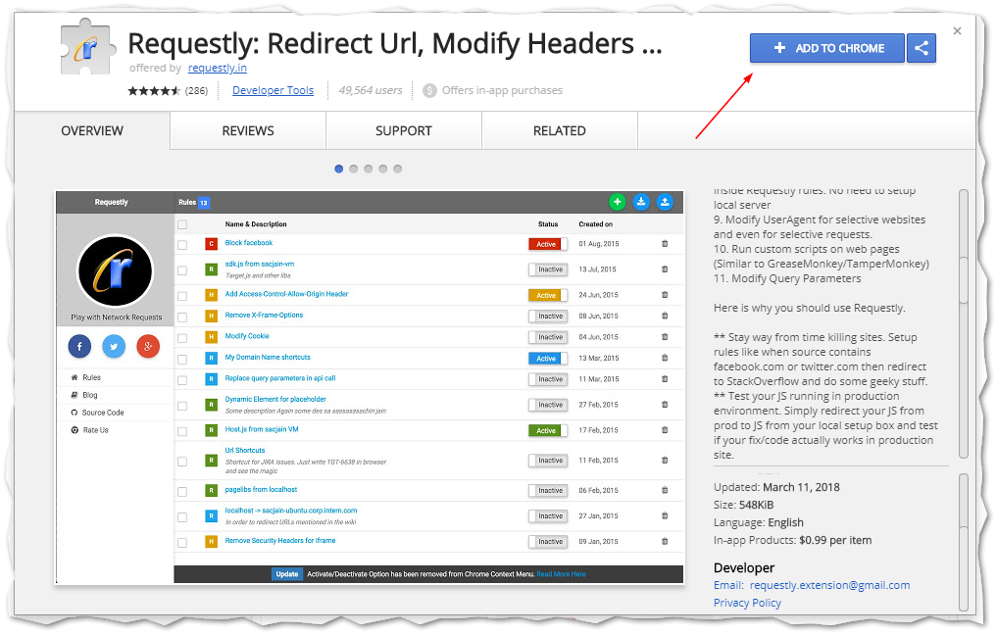

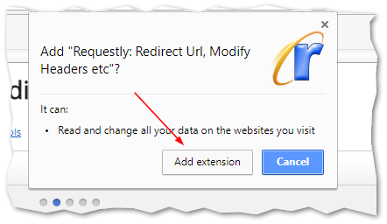

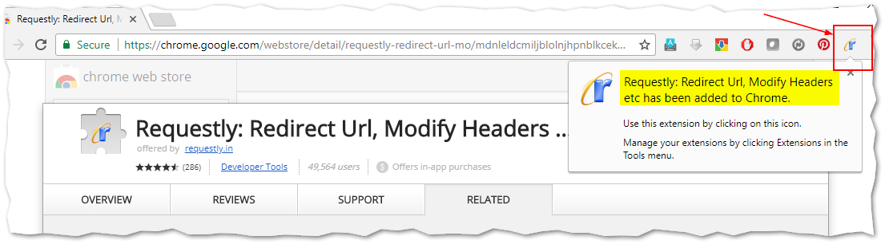

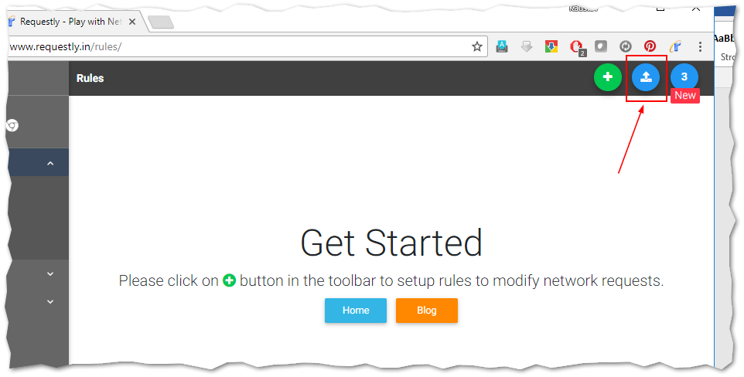

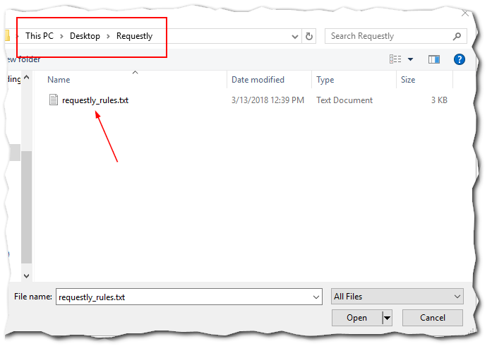

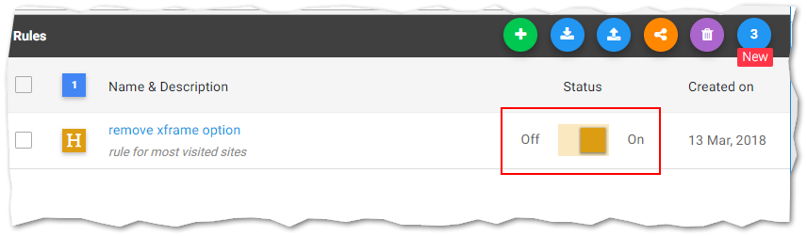

## Setup for Firefox

Go to <https://www.requestly.in/home/> and add the addon…

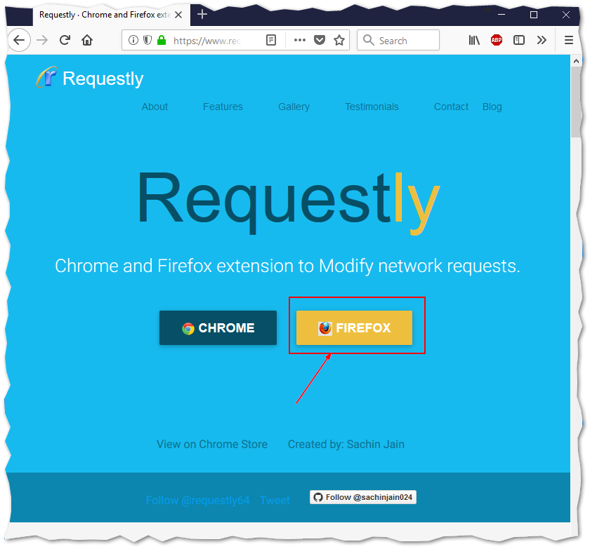

Follow the chrome section of this doc to understand how to import the ruleset